

From Migrating Cell to Shape Space

# Terminologies for the Tutorial

To make the tutorial easy to read, a couple of terms are introduced:

* Movie folder: the folder containing your microscopy data
* Analysis folder: the folder containing all files; the tutorial assumes all output files from all steps are saved in the Analysis folder, apart for one step ‘Out of Sample Extension, or OoSE, in step five.
* Run a “specificMatlabFile.m”: this means, the path is added to your path, and a click on the “Run” button in the toolbar executes the program. Should these instructions feel unfamiliar, read the next Section “New to Matlab”
* Matlab: Please install MatlabR2013b. The program is only tested with this edition on Mac OS X. Matlab offers earlier versions in its Download center, which you have access to.

A check in from Anne

# New to Matlab

If you have never used Matlab before, you should to install the program and obtain a license first. Most universities offer free licenses for staff and students.

A comprehensive guide can be found at Mathworks

<http://uk.mathworks.com/help/install/installation-and-licensing-fundamentals.html>

For the tutorial, we recommend the version **MatlabR2013b**, to guarantee all functions are working properly. To download perform please the following steps:

* Login to [www.mathworks.com](http://www.mathworks.com)
* Click My Account
* Click "Download Now" under Account Services, below the wording "MathWorks Account
* Click Download on the next page (under Licensed Products and Updates)
* On the following screen, there is a selection of newest release. To the right of the most recent version link, there is the link "Choose another release"
* After clicking select MatlabR2013b and proceed with download
* NOTE: This facility is not available for Student Version or trials since they are version specific.

To run the tutorial, you need the folder ShapeSpaceExplorer containing all files. Within the Matlab program go to the folder “ShapeSpaceExplorer” (see figure below).



Then, right click on ShapeSpaceExplorer folder, and select “Add to Path” 🡪 Selected Folders and Subfolders (see below)



This adds the ShapeSpaceExplorer to the Matlab paths, which means, the programs are easy to execute. The ShapeSpaceExplorer folder should appear as active (see figure below)



To run a program, open ShapeSpaceExplorer 🡪 1-ImageSegmentationFull and select the File “Run\_CellSegmentation.m” with a double click (see below). Then click on the “Run” button in the Toolbar. The first line in the command window should then contain the line   
>> Run\_ Run\_CellSegmentation

One a program has finished properly, the program lines writes at the end:

>>

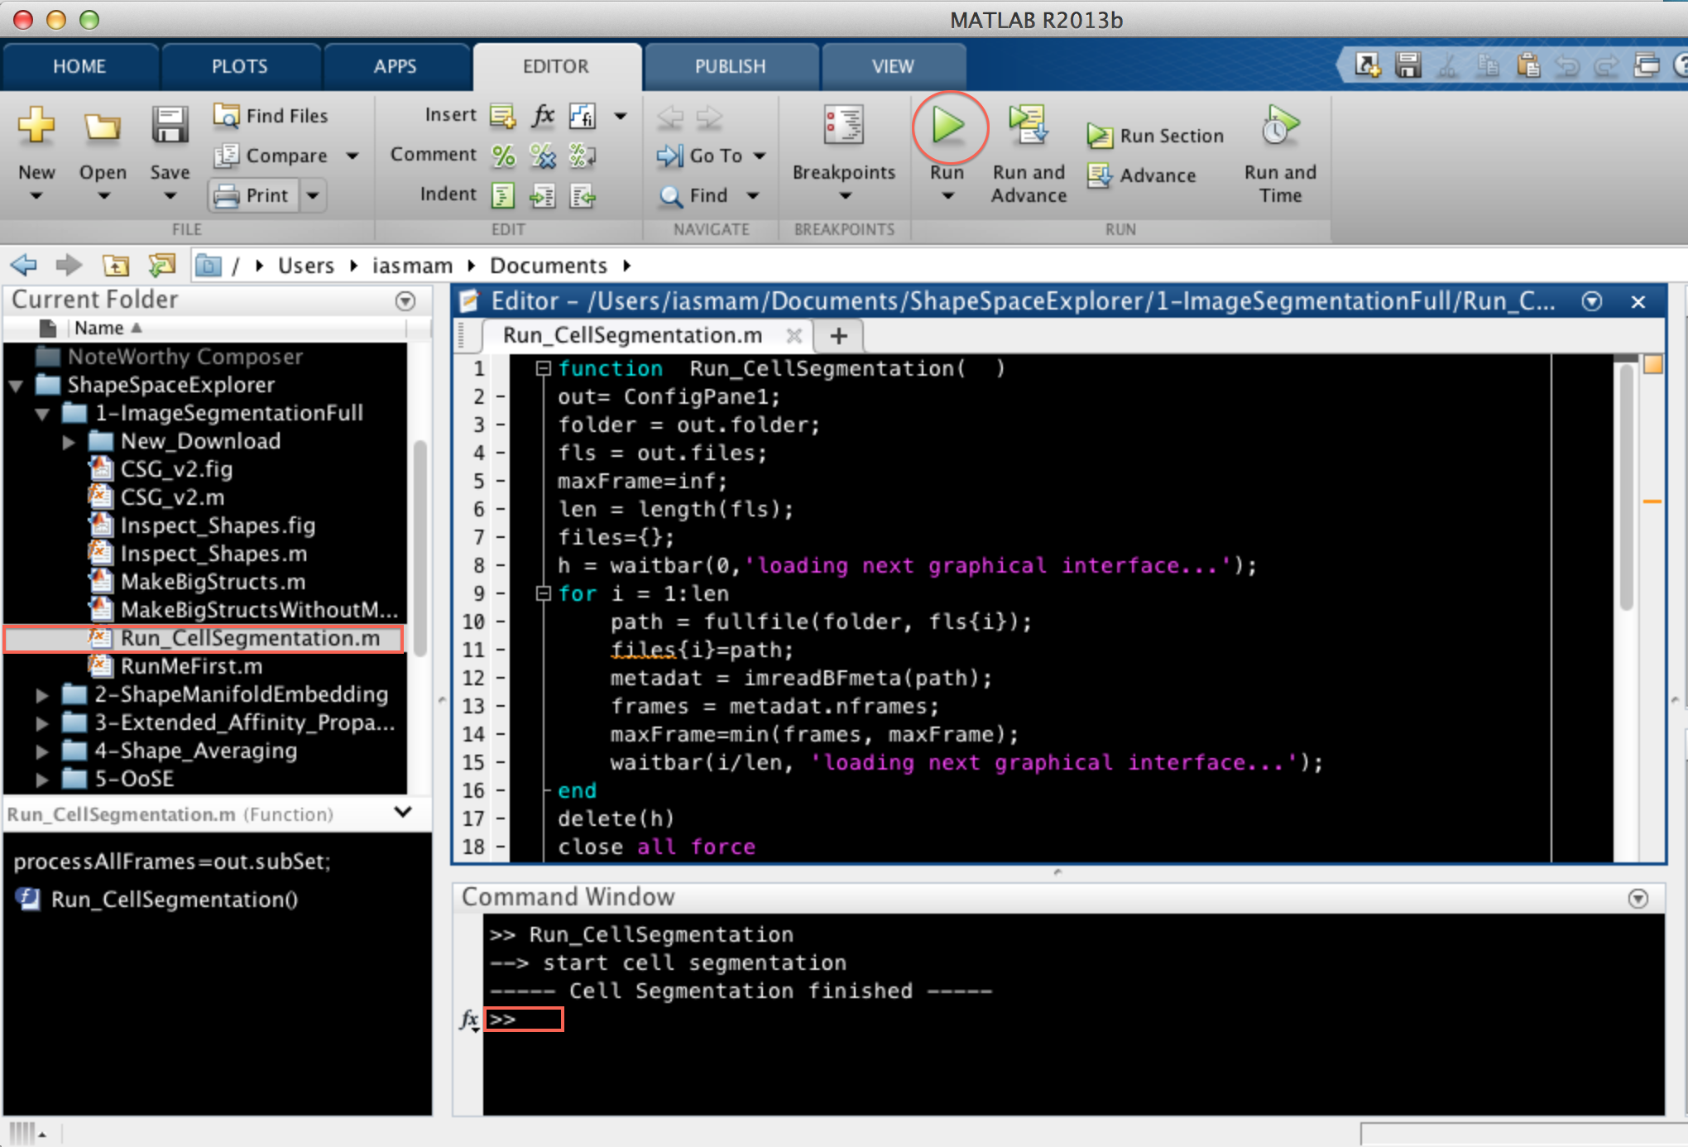

1st Step : Cell Segmentation

Cell Segmentation starts with the microscopy data in your Movie folder saved in “.DV” file format.

To run cell segmentation, go to ShapeSpaceExplorer 🡪1-ImageSegmentationFull, open the file “Run\_CellSegmentation.m” and click on “Run” which should show the interface below:

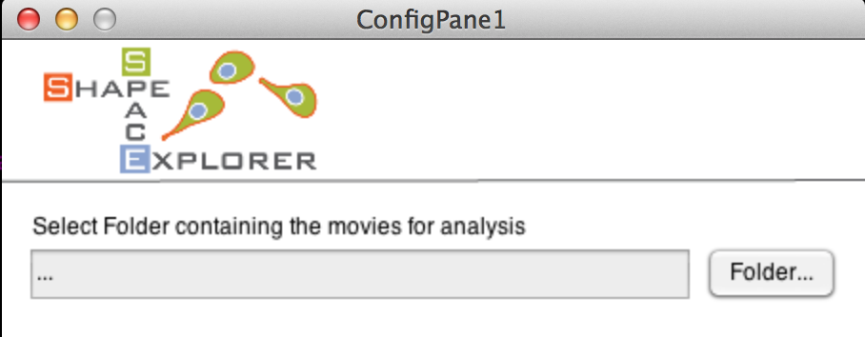

Select your Movie folder containing your microscopy data, which should show all the files in a selectable list (see below).

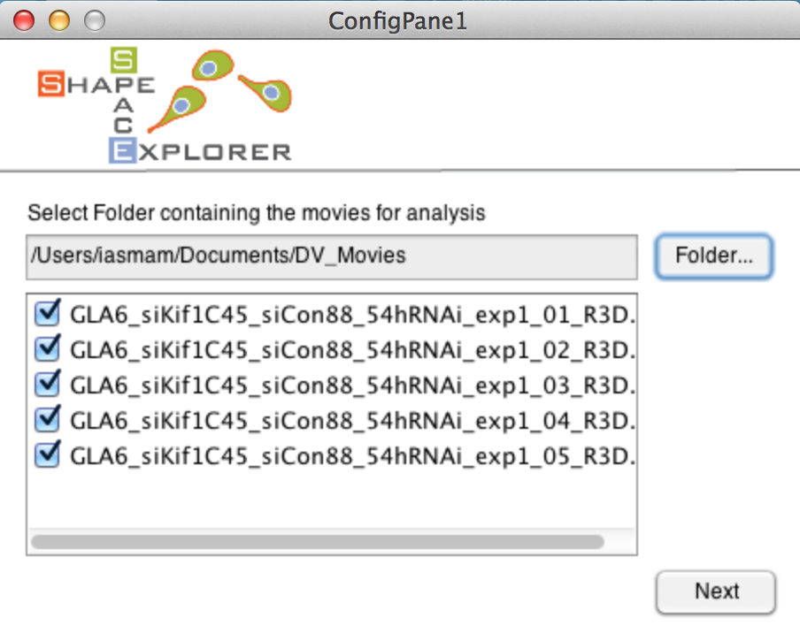

Select all movies that should be analysed. Note that at least one file must be selected to continue which should lead to the next interface (see next page). Note, the loading of the interface is slow, because it calculates the number of frames of your shortest movie from all movie files.

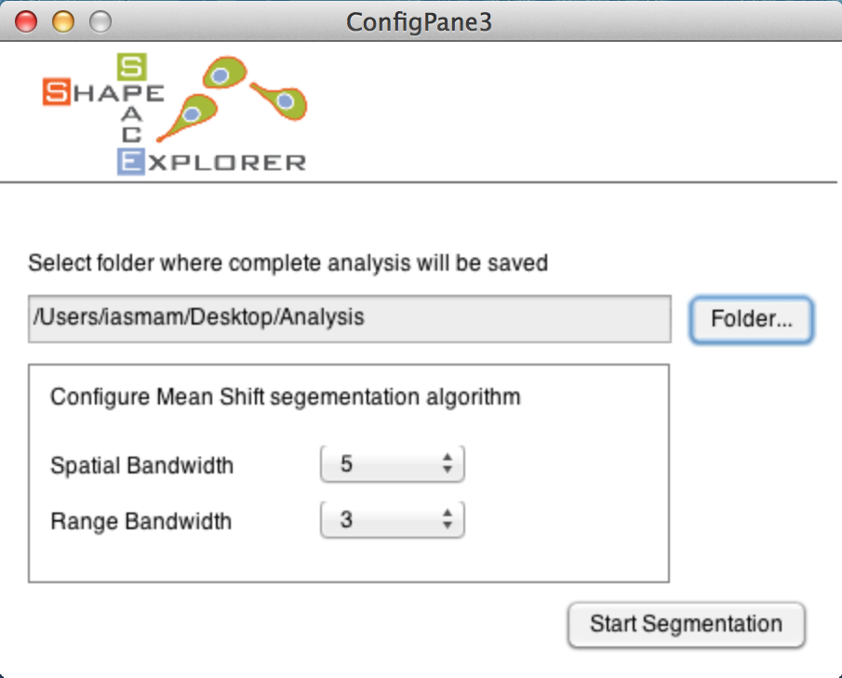

The interface offers two choices: first to analyse all movies from start to end (default choice) and second to select a substack of your frames, which might be helpful if your data went out of focus. Should you select a substack from frame A to frame B, this selection is automatically applied to all movies in your analysis.

The final interface asks you for the Analysis folder to save the output of the cell segmentation (see below). Clicking on Start Pre-processing starts automatic cell segmentation. This is a time intensive task and can take several hours to a few days depending on your data size.

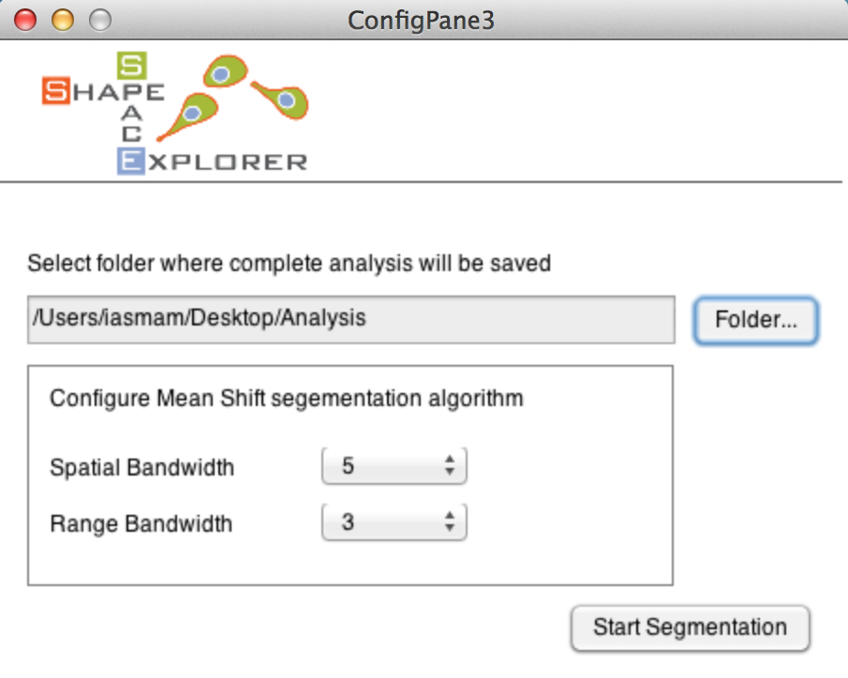

Two waitbars indicate the progress of cell segmentation. At the end, the commando line prints a note when the program finishes successfully (see example below).







The Analysis folder should have the following new files:

* ImageStackXXX.mat for each selected movie
* ImageStackXXXCurveData.mat for each selected movie
* FileMapping.csv: contains the mapping between the new movie names and the original movie names from the Movie folder. Excel can import CSV files.

Caveat for Cell Segmentation

The cell segmentation used in ShapeSpaceExplorer uses an implementation of the Mean Shift Algorithm with the EDISON wrapper (**E**dge **D**etection and **I**mage **S**egmentati**ON**), The reference and details of the algorithm can be found in: D. Comanicu, P. Meer: "Mean shift: A robust approach toward feature space analysis." IEEE Trans. Pattern Anal. Machine Intell., 24, 603-619, May 2002.

NOTE: Should the segmentation produce strange outputs, then there are two parameters to adjust the algorithm: Spatial Bandwidth and Range Bandwidth.

Generally speaking, the range bandwidth influences how much noise the cell segmentation picks up. Should there be too many smalls blobs recognized as cells, this parameter should be increased.

The spatial bandwidth, influences on how the radius of a detected shape can be where the selected three pixel referred to as smallest possible radius. Depending on your imaging conditions and average size of your cell, the interface permits to fine tune the cell segmentation step. Though, the proposed default values worked for a white range of cases.

An excellent explanation on how the parameter influence cell segmentation can be found on Wikipedia: <http://en.wikipedia.org/wiki/Mean_shift>.

Manual correction of Cell Segmentation

To inspect the cell segmentation results, run the file 1-ImageSegmentationFull🡪 Inspect\_Shapes.m in the ShapeSpaceExplorer folder producing the interface below:

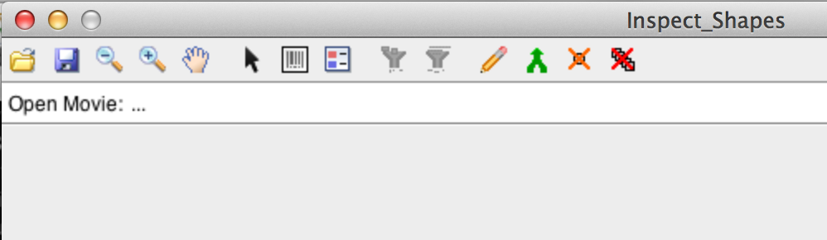

Click on the folder icon in the toolbar and select one of the files with the name format ImageStackXXX.mat, for example ImageStack001.mat. The program highlights the contours of the detected cells. The toolbar offers zoom in, zoom out and pan operations. The 8th icon from the left is the legend icons and permits you to see the id assigned to detected shapes.



There are a variety of operations that permit to correct the automatic cell segmentation manually. Each of the operations is explained in the following sections.

Delete a single Shape



Selecting the Cursor and clicking on a shape removes the shape from the detected cells, indicated by a grey outline. To remove a shape from a frame plus all future frame you need to hold down the key CTRL and click on the shape. To add the shape back to detected shapes, simply click with the Cursor selected inside the shape, which should re-colour the shape in a bright colour.

Filter out shapes with small area size



The filter is applied to the complete stack. All active shapes smaller than your minimum size will become deselected.

Filter for sort live span



Merge



Manual Drawing



You have the full functionality of the Matlab ROI tool,

Full Description here: <http://uk.mathworks.com/help/images/ref/roipoly.html>

* Delete: Backspace
* Adding a new vertex: Key A
* Delete vertex: right click, and select delete
* Closing Polygon: Move to an existing point and click on it.

Continues tracks

For the analysis presented in this tutorial, continuous tracks are cell tracks that stretch from a start frame to an end frame, without any interruption. The cell with id one, appearing from frame one to five [1,2,3,4,5] would be an example.

However, if the track would have a missing frame, say at frame three, so that the sequence is [1, 2, 4, 5], then when the program saves your modification, it will assign a new id to the second part of the track.

When you save 3 new files should be produced:

* CellAray001.mat
* CellFrameData001.mat
* ManCorrtdCrves001.mat

# After manual correction

Say, you have corrected all files, then you are ready for the next step: in Folder 1-ImageSegmantation Full, there is the file MakeBigStructs.m

Open it in Matlab and click on the “Run” Button.

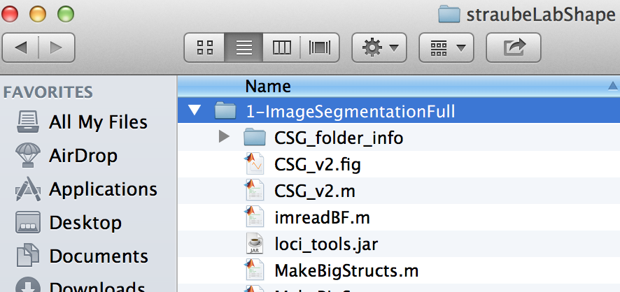

There should be an explorer that opens, and you should enter as the directory, the experminet directory you have been using.

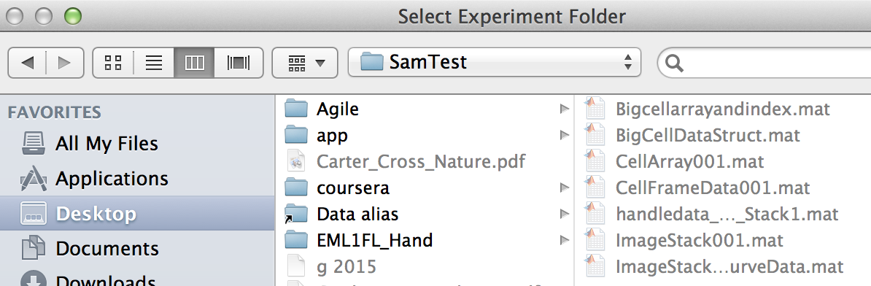

After selecting the folder, the program should create 2 new files in the folder, namely Bigcellarrayandindex.mat and BigCellDataStruct.mat (see below).

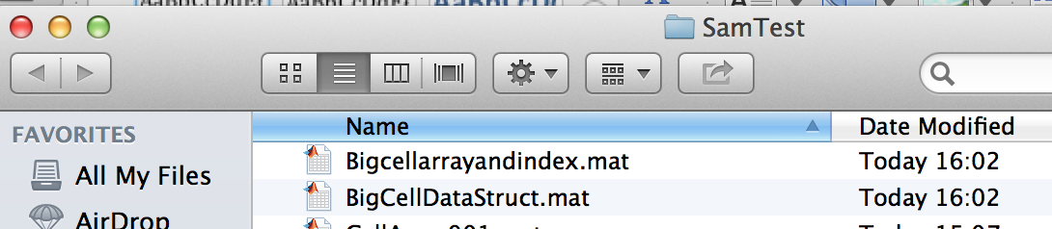

“2-ShapeManifoldEmbedding”

BAM calculates the distances.

open the script “RunShapeManifoldEmbedding.m” in Matlab. Click on the “Run” Button in Matlab, and the script should ask you for experiment folder (as before). Select the folder and when the script complets correctly, you should see the following dialog box.



Also, if the program run correctly, you should have the file “CellShapeData.mat” in your experiment folder.

Now you are ready to move to the steps in Folder

# 3 Extended Affinity Propagation

This step will cluster your sample according to the similarity of cell shapes. All files to complete this steps, will be in the folder   
“3-Extended\_Affinity\_Propagation”

The first preparatory stop consists in running the Affinity propagation. To do so, open the file “Run\_Affinity\_Propagation.m” in Matlab and click “Run”. The program should open a File Chooser for your Experiment Folder, the folder where you have saved the files of the previous steps. After selecting the folder, the program should start automatically. Progress of the program can be seen on the console. When the program finishes, you should see the following progress bars.



Once the program finishes successful, there should be nine new files in the folder, which should have the following names:

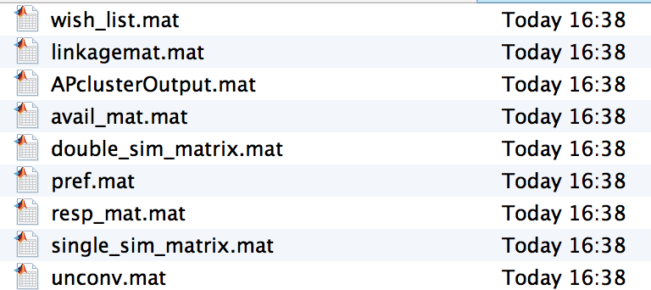

Inspecting the classification of shapes

Now you are ready to inspect the classification of shapes.

Open “Inspect\_ShapeAffinity.m” and click on Run. The program should open a Folder Chooser, where you can select the Experiment Folder. After selecting the file, the program should run straight away, and produces the following two files.

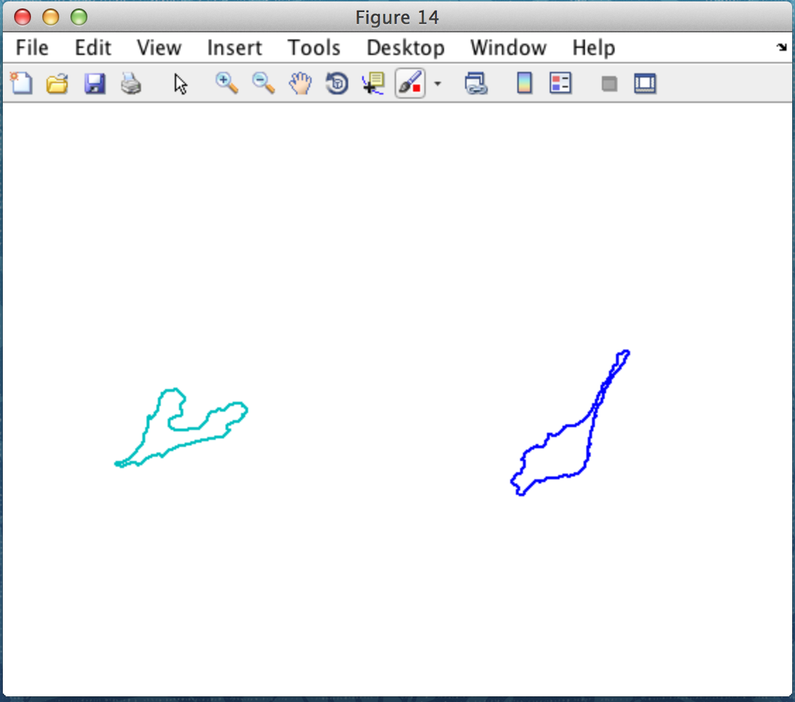 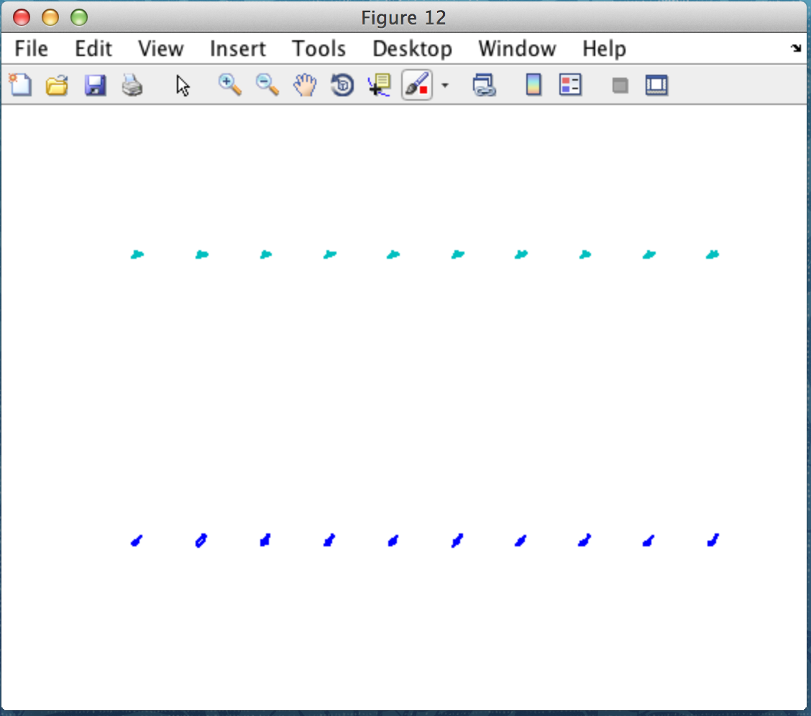

The figure on the left shows a representative sample for each cluster, while the figure on the right shows ten representatives for each clusters. The program saves automatically the figures under “Experiment Folder/Figures”

With the following file names:

* 3\_AllShapes\_Example\_foreach\_Cluster.fig
* 3\_AllShapes\_Example\_foreach\_Cluster.fig

Dendogram of Shapes

Sometimes, the previous step might produce too many shape classes. You can force the classification of shapes to use less clusters. To make an informed choice, you should to have a look at the dendogram of shapes first.

To generate the dendogram of shapes, open “Run\_Dendogram\_of\_Shapes( )” and click on “Run”.

The program should open a File Chooser and you should to select the Experiment folder. Upon successful completion, the program produces a dendogram, which is automatically saved as  
“Experiment Folder/Figures/ 3\_Dendrogram\_of\_Shapes.fig

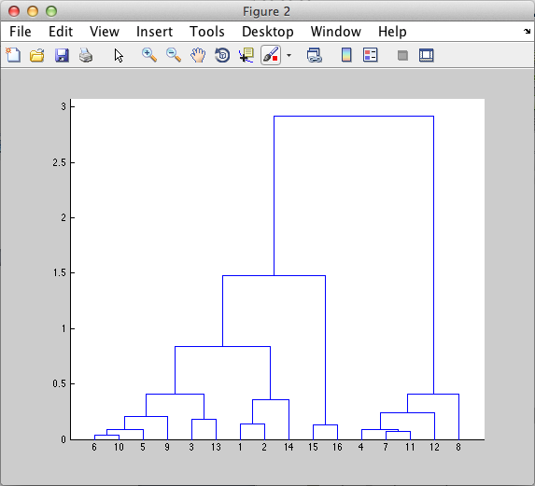

After running the dendogram, you should determine a number that is more appropriate for clustering your shapes. This number is important for the next step.

Then you are ready to run the next program: Open “Run\_constrained\_Clustering()” and click “Run” you should see the following graphical interface:

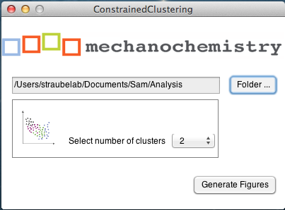

You need to click on the “Folder” button and select the file Analysis folder which should contain a file called “CellShapeData.mat”. Then select the number of classes you would like to limit you shape clustering. This number must be smaller than the maximum number of clusters you have in the dendogram! Ideally your choice should be informed by the dendogram you generated before.

After selecting an appropriate number and clicking on “Generate Figure” you should get the following two figure:

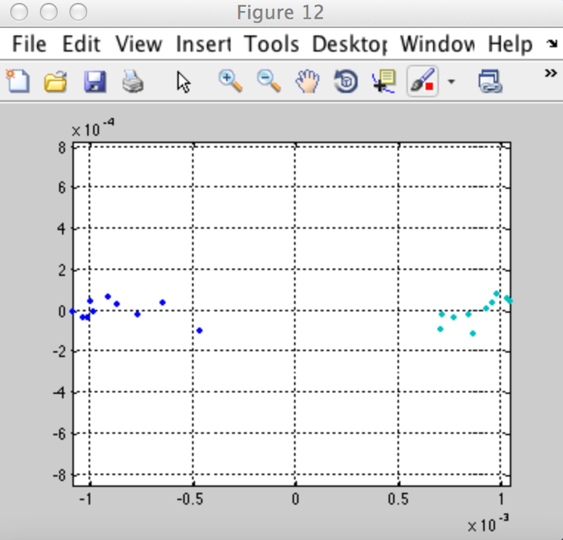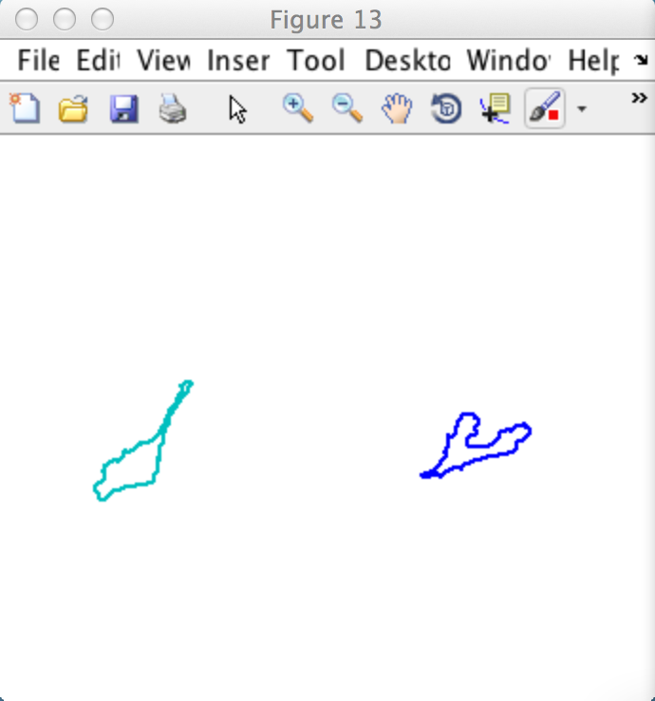

The figure on the left shows the coloured clusters in shape space. The figure on the right shows a typical representative for this cluster. These two figures are automatically saved in the Experiment Folder/Figure/ with the following in the following files:

* 3\_Avg\_Shape\_for\_Clusters.fig
* 3\_Coloured\_Shape\_in\_ShapeSpace.fig

# 4 Shape Slicer

To run the shape slicer, you need to go to folder “4-Shape\_Averaging”, open the file “Run\_SpaceSlicer”, and click on the “Run” button in Matlab. You should then see the following graphical interface. You click on the button “Folder” to select the Analysis folder, which should contain the Matlab file “CellShapeData.mat”

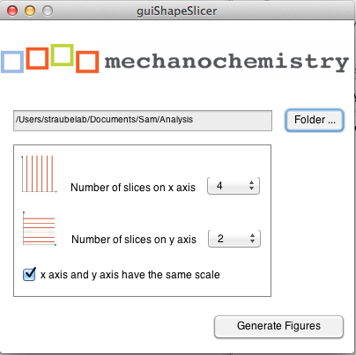

Figure 1 Shape Slicer GUI: Select CellShapeData.mat and configure the slices for the x and y axis.

The graphical interface allows you to configure the slices on the x and y axis, and whether you would like to force the two aces to be on the same scale.   
Once parameters are chosen, click on “Generate Figures” and the Shape Slicer should produce the requested figures.

When the program runs successfully, you should receive four different figures as output. One of those figures should look somewhat similar to the figure below. If you click on the figure under File 🡪 Save As… you can save the figure in vector format and modify with any graphic program.

Note: The program automatically saves in your “Experiment Folder🡪 Figures” all the figures that are generated. However, they are overwritten each time you generate new figures. All four figures begin with a name “4\_ShapeSlicer\_\*\*\*” to help you identify the figures for this step in the process.

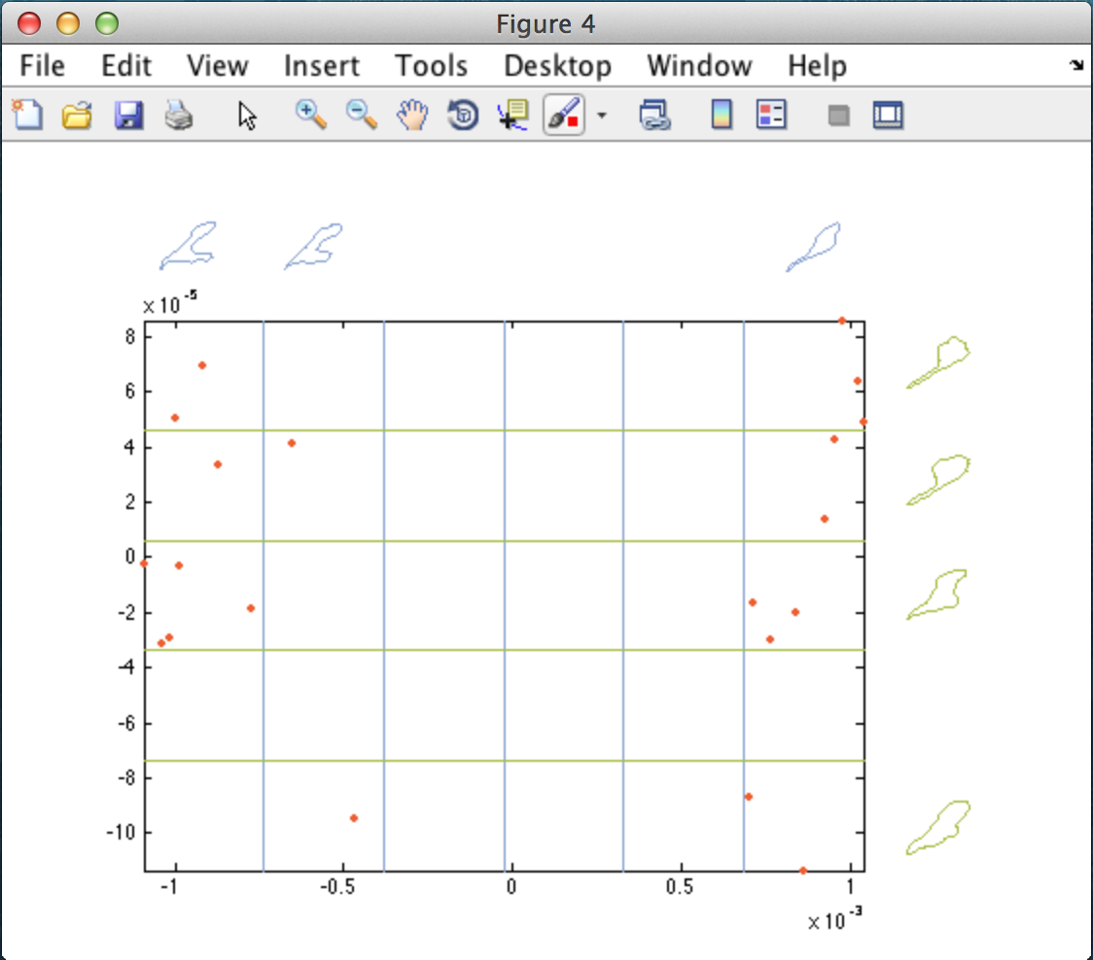

Figure 2 Sliced Shape Space: blue figures indicate average space in slices along the x-axis, green figures indicate average shape in slices along the y-axis.

However, the program also produces the single parts of the programs individually, e.g. the average figures along the axis as well as only the content, permitting maximum flexibility in graph creation.

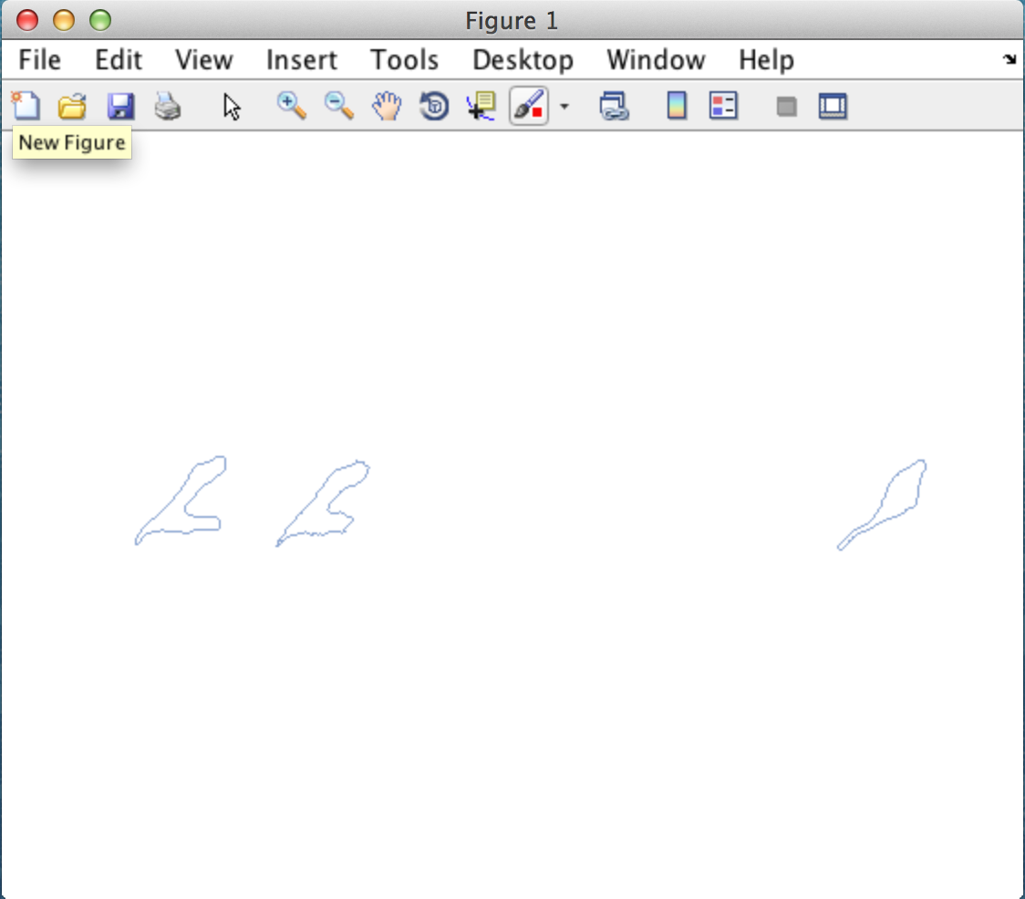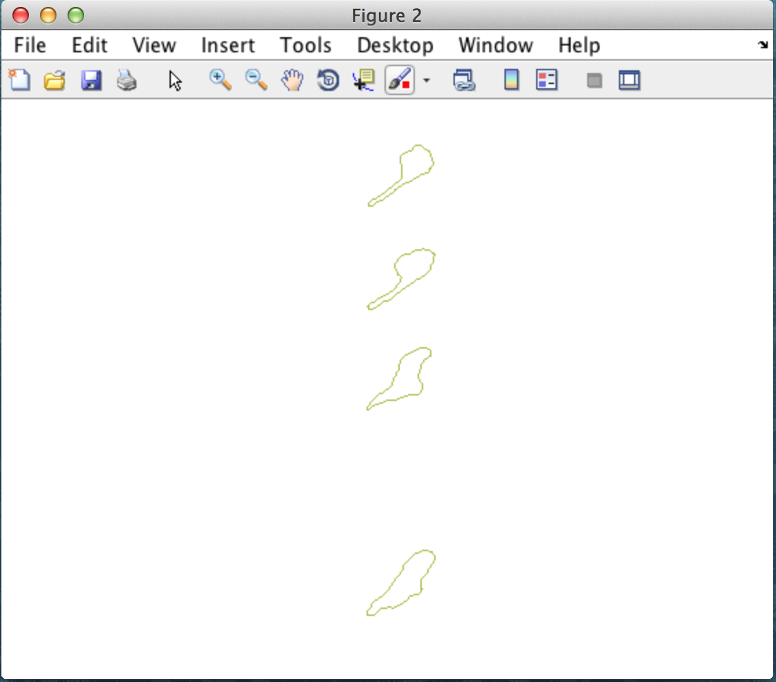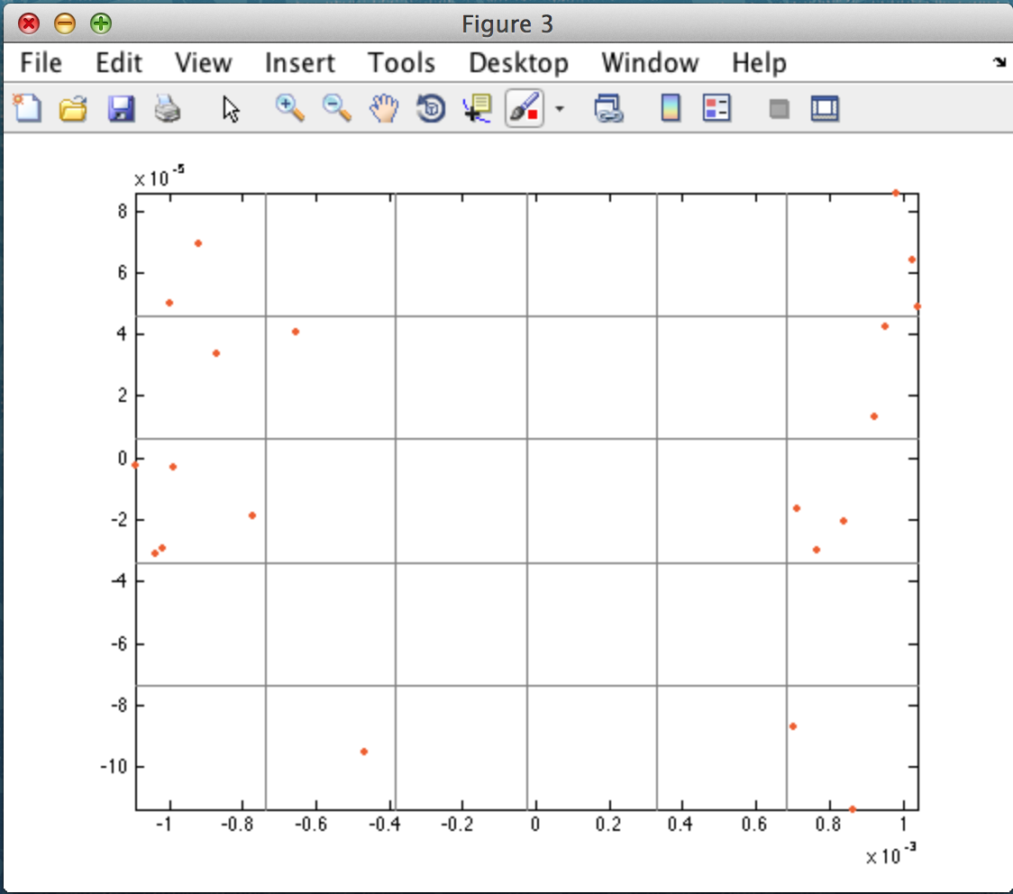

Figure 3: Partial output: left average figure along the x-axis, middle average figure along the y-axis, and shape in the sliced grid.

# Group Analysis

You might like to have a group analysis of space shape and clusters for your sample. Say, you would like to divide your sample into three groups, with Group1 is your control, Group2 is your first treatment and say Group 3 you second treatment. Then, these steps show you how to obtain Groups highlighted in clustered shape space, get their respective percentual in barplots, their average speed and persistence.

First select your Analysis folder and the number of clusters you would like to divide shape space.

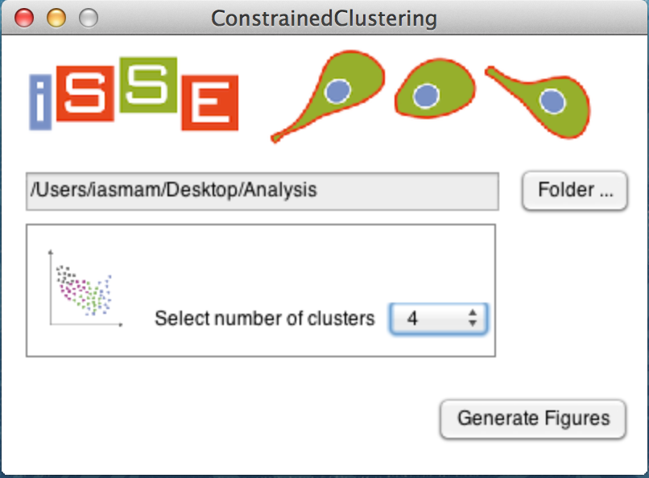

Next you have to define the groups in this graphical interface. 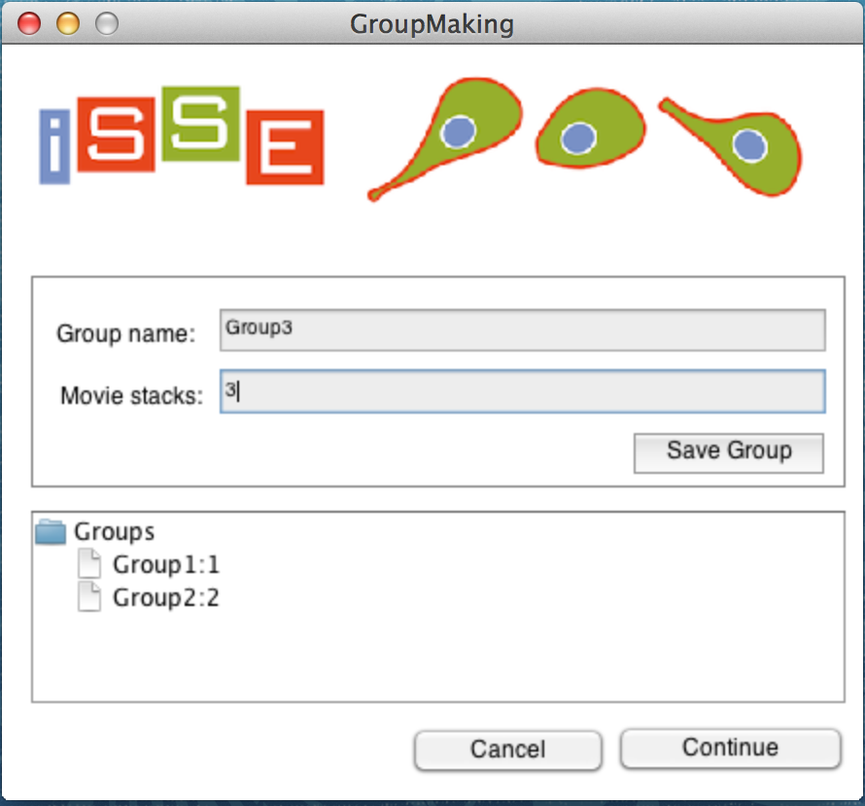

In Groupname, you enter the name of the group. The name should start with letters, as this is used for many files created automatically. Please do not use white spaces or special sign, they might cause issues.

Movie stacks: here you enter the numbers of the movie stacks, that should go into the groups. You can enter the numbers for a set, such as from movie 1 to 5 as follow:

* 1, 2, 3, 4, 5
* 1-5

The mapping between your original movie names, and the newly renamed ImageStacks in your analysis folder can be found in the file: “FileMapping.csv”.

Once you are happy with the Groups, you can click “do Analysis”.

A folder “GroupAnalysis\_2015-04-15\_095836” with a Time stamp at the end is generated. There you will find the following Analysis.

Macintosh HD:Users:iasmam:Desktop:Analysis:GroupAnalysis_2015-04-15_095836:Group1_ShapeSpace.eps Macintosh HD:Users:iasmam:Desktop:Group2_barplot.eps

Left figure shows shape space, with all figures of all groups (empty circles) and the highlighted circles from our Group1, across the four selected clusters.

Right figure shows the frequency of the shapes in each cluster in percentage.

Macintosh HD:Users:iasmam:Desktop:Analysis:GroupAnalysis_2015-04-15_095836:Cluster_1_barplot_count.epsMacintosh HD:Users:iasmam:Desktop:Analysis:GroupAnalysis_2015-04-15_095836:Cluster_1_barplot_percent.eps

For all clusters, there are percentual and absolute frequency bar plots (see above), giving insight how across clusters the frequencies are distributed.

Macintosh HD:Users:iasmam:Desktop:Analysis:GroupAnalysis_2015-04-15_095836:Group1_Persistence_Angle.epsMacintosh HD:Users:iasmam:Desktop:Analysis:GroupAnalysis_2015-04-15_095836:Group1_Persitence_EucledianRatio.eps

Persistency: Left figure shows the angles for the Group1. Within a track of shapes from one single cell, the angle between two points was calculated by first

* obtaining a, b, for the function y=ax+b from two points.
* Obtaining theta= arctan(a)
* Putting all in rose plots.

The second is the ratio between Euclidian distance between two points, divided over the accumulated distance, and then histogram of these values.

Finally, the Average Speed in shape space for each of the Groups is written in “AvgSpeedPerGroup.csv”

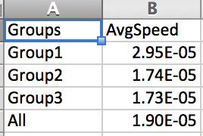

# 5 Out of sample extension

First step: create a folder called OOSE in the Experiment Folder.

You also need to have done all the steps from 1 to 4, and have an experiment folder with all necessary files.

* Run\_CellSEgmentation (as described in Section) but save all the results in the OOSE folder.
* Correct Data manually, using “Inspect Data” as described before.
* Run “Make\_Big\_Structure in the OOSE folder.

These are the preparatory steps before you are ready to start.

Now, in the 5\_OoSE folder open the program “run\_OoSE\_training” and click “Run”: You should see:

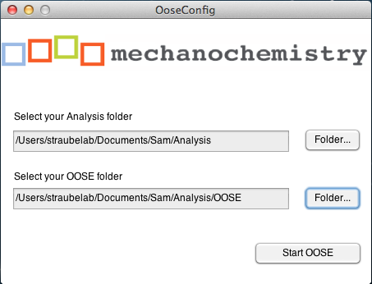

Select your Analysis folder for the complete experiment and your new OOSE folder, and then click “Start OOSE”.

If the program runs successfully, you should see the following on the console.

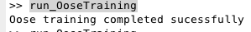

Plus in the OOSE folder, the file: LP\_trained.mat should be newly generated.



The structure inside LP has a Nx5 matrix. N is the number of frames we analyzed.

In the next step, we create a distance matrix. Open the program “generate\_OoSe\_distMatrix” and click “Run”



Again you select your Analysis and your OOSE folder for your experiment and click on start. You will see progress bars. There are 3 steps to be completed, and the last one “Embedding” is quite slow and the progress seems frozen. Please be patient., program is still running.



After finishing you will see a message on your console.

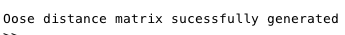

Also, in your folder there should be the following 2 files newly generated.: Dist\_mat.mat, OoSE\_embedding.mat

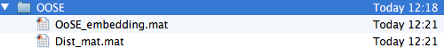

Now we would like to see how our complete sample of shapes compares to our out of sample set. To see this, we run “compareBargraphs()”

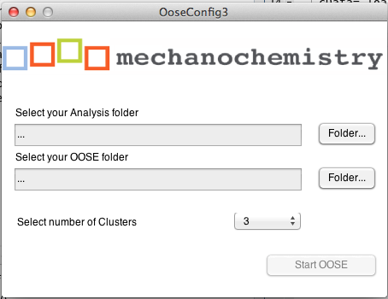

For Clusters, we choose the number we got from “3 Extended Affinity Propagation”. And select the Analysis folder with all the Data, and the OoSE folder with the out of sample Extension.

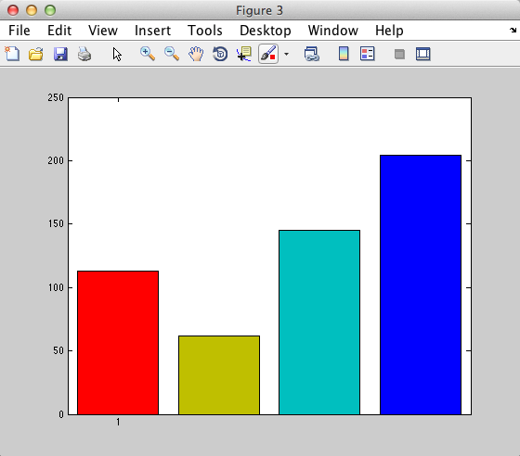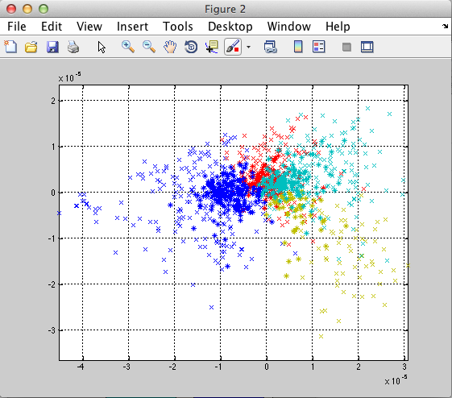

Now, the light crosses show the clustering of all data sets, while the dark star shows how the data from the OoSE set. The bars show how many shapes are in each of the clusters from the OoSe data set.

The figures are saved as

* 5\_OsSE\_dots.fig
* 5\_OsSE\_bargraph.fig

# 6 Display Shape Features

Open the File “Run\_ShapeFeature\_Processing” and click on “Run” in Matlab.

The program should ask you for the Analysis folder. The process is calculation intense. Please be patient.



After processing you should have a new file in the Analysis folder.



Then you open the program: generateShapeFeature and click on “Run”

You should see:

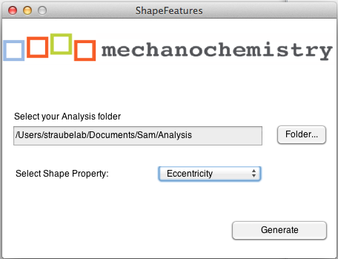

Select the Analysis folder and one of the Properties the Shapes should be analyzed, for example Eccentricity. Then click on Generate and a figure should appear.

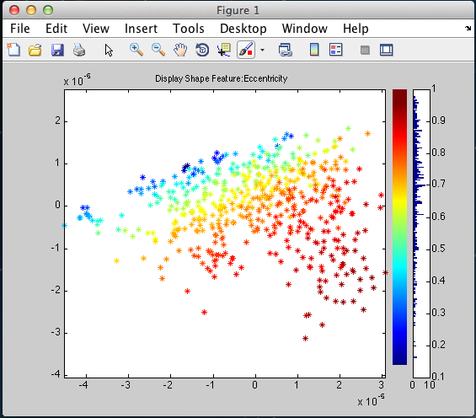

## Interactive Shape Explorer

This one allows you to interactively look at a single cell, its track in shape space, and its contour plot over time. To do this, open in Folder “6-ShapeFeatures”, the program “CellTrackViewer” and click “Run” and see a program as in figure below.

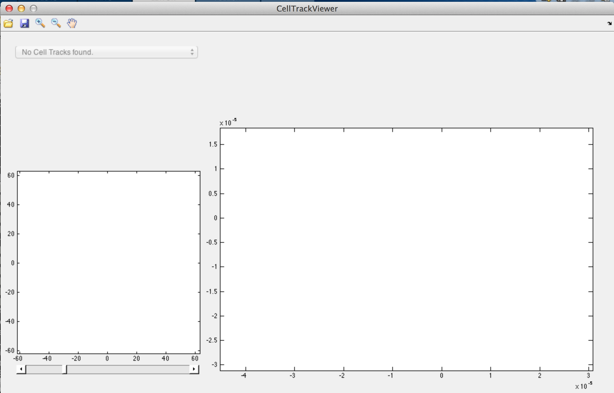

Click on the folder icon, and select an “ImageStackXXX”.mat file from your Analysis folder.

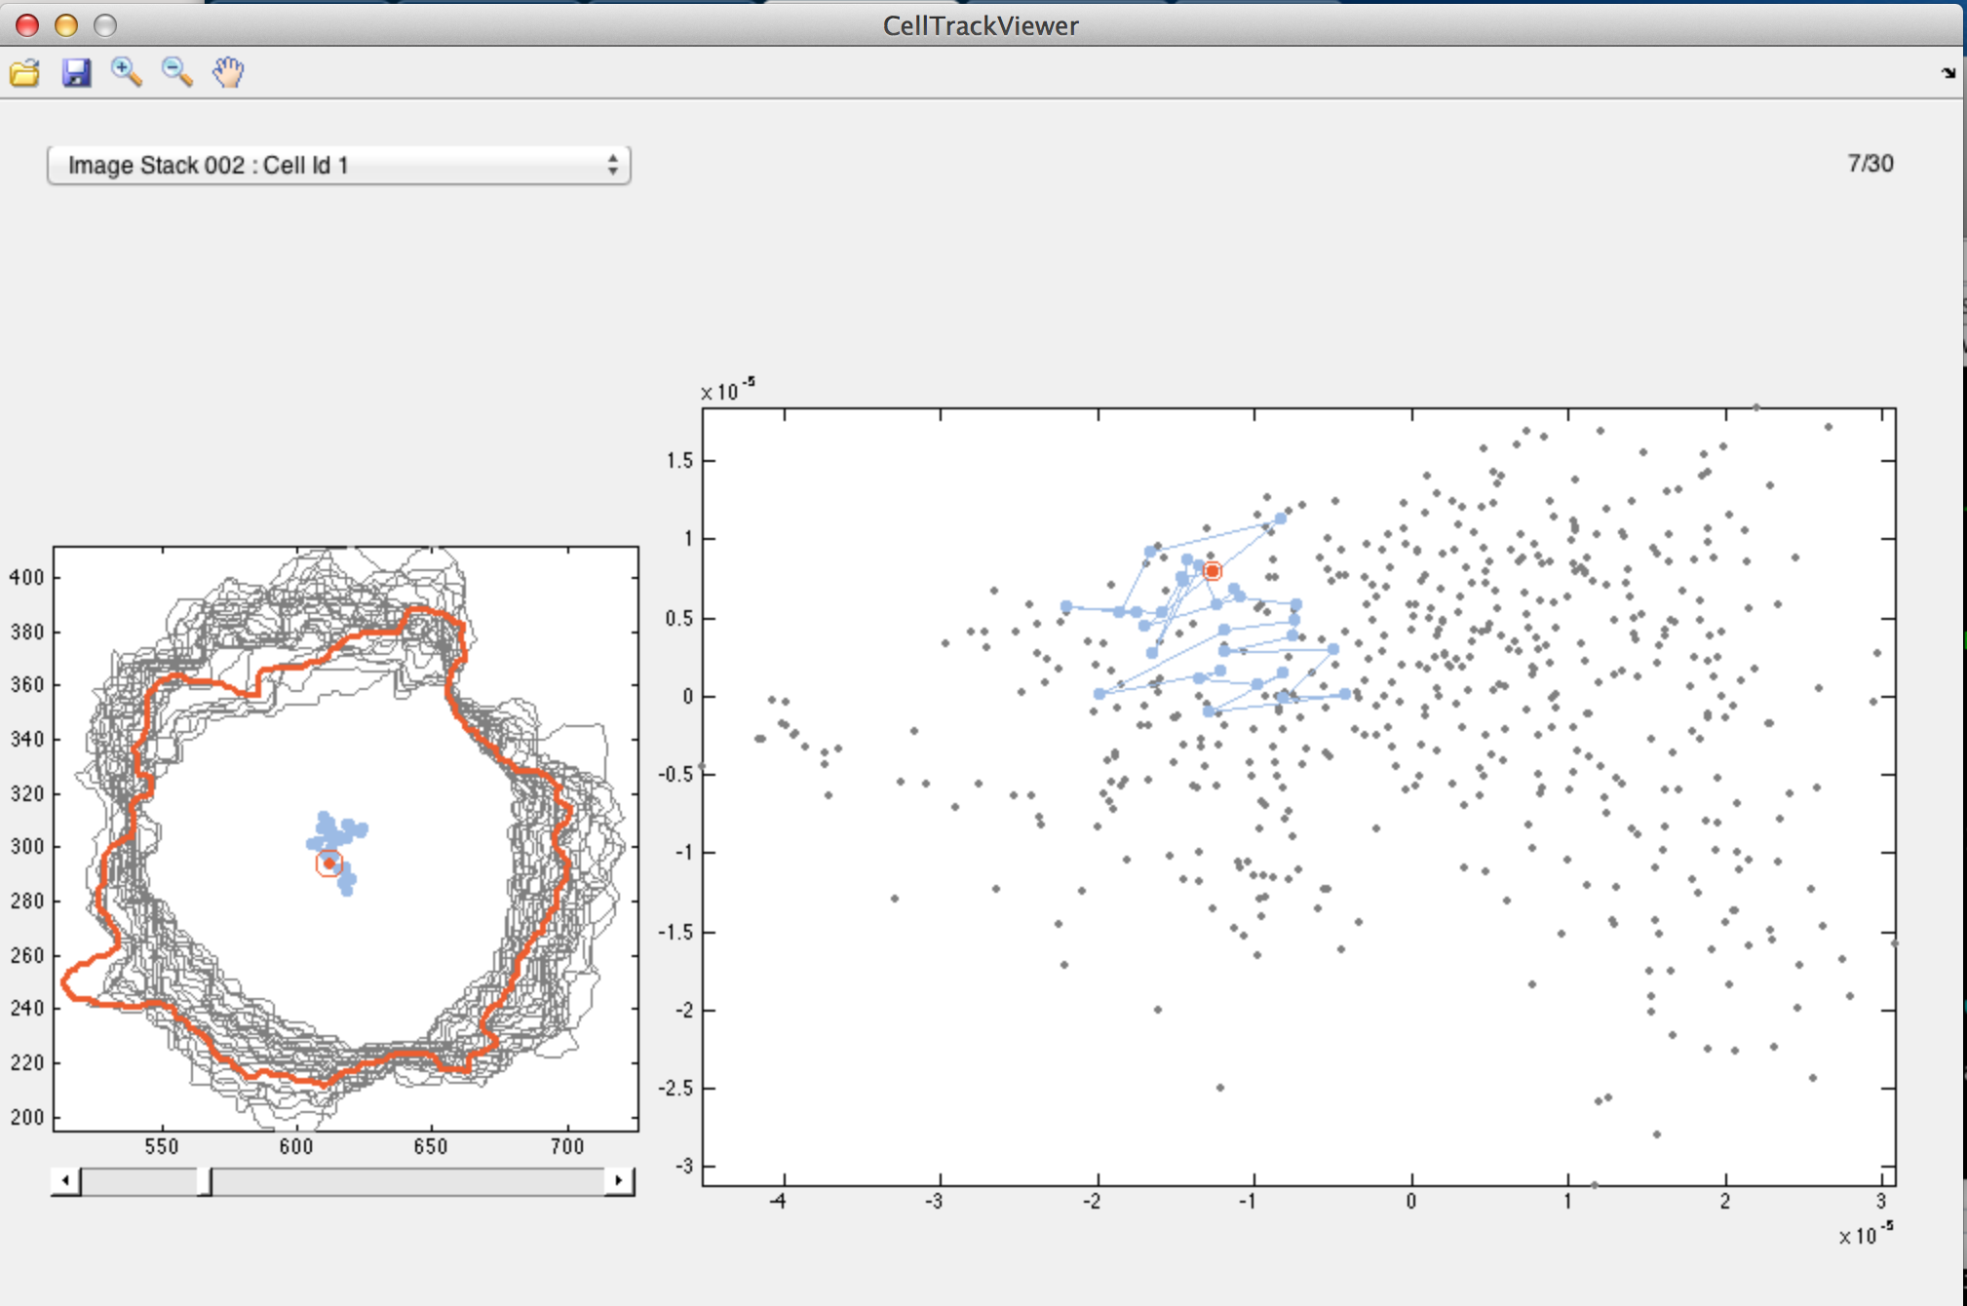

The program loads automatically the first track of the first cell id. The drop down lets you select the tracks of other ids. The numbers are not continuous, since empty tracks are not loaded. The ids are the same as you see in Folder X, Program X.

# Step 7 Shape Space Dynamic

In order to generate plots showing shape space dynamic, the program has to start with a pre-processing step. For this, you open the program “Run\_DynamicData\_Generation” and click “Run”.

If the program was successful, you should see on the console the following message:

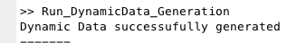

And in your Analysis folder, there should be the following new File:



If you open the structure in Matlab, you will see that DynamicData consists of an array of structures, with the following fields:

* struc.track: contains the x,y coordinates for this cell id in shape space, for each frame.
* struc.track: contains the speed for this cell id, for each frame.
* struc.average\_speed: a single number, containing the average speed for this cell id.
* Struc.angles: contains the angle of a cell id for each frame it appears.
* Struc.av\_displacement\_direction: a single number.

If we have N different cell ids segmented, we should have N structures in this array. However, the method for future application will filter for cell id s with missing frame. In order to be comparable, we assume equal time points. Also cells with less than 2 frames have been filtered out.

### Sliced Shape Space Average Dynamics

Similar to slicing the shape space and see the average cell shape in the segements (as done in step four), the program allows us to analyze an average behavior for the slices.

When starting the program, we open the file “Run\_Sliced\_Dynamics” and click on run:

Choose your experiment folder which should contain the file “DynamicData.mat” from the previous step. Also add the number of vertical and horizontal slices as desired. Then click the button “Generate Figures”

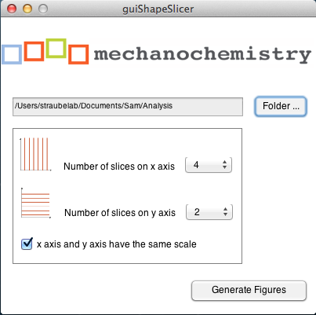

The program should produce a figure that looks similar to this:

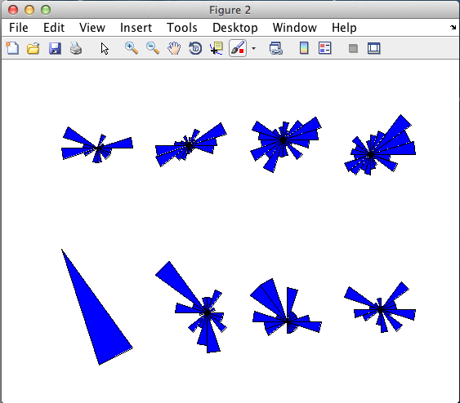

### Explore Average Behavior of clustered space

To explore the dynamic behavior of shapes of the cluster’s within space shape, we need again the number of clusters. This number has been determined in step 3, by generating the dendogram.

To generate the diagram, open the file “Run\_Clustered\_Dynamics.m” and click run:

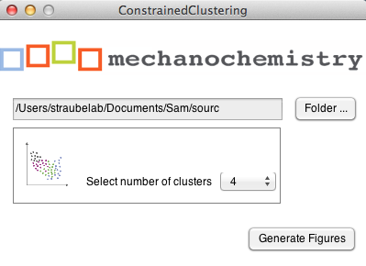

Select the Analysis folder and how many clusters the shape space should be divided into; in this example four was used. Before running the experiment, check the following files are in your experiment folder:

* DynamicData.mat
* CellShapeData.mat
* APclusterOutput.mat
* wish\_list.mat
* Linkagemat.mat

An example graph could look similar to the image below:

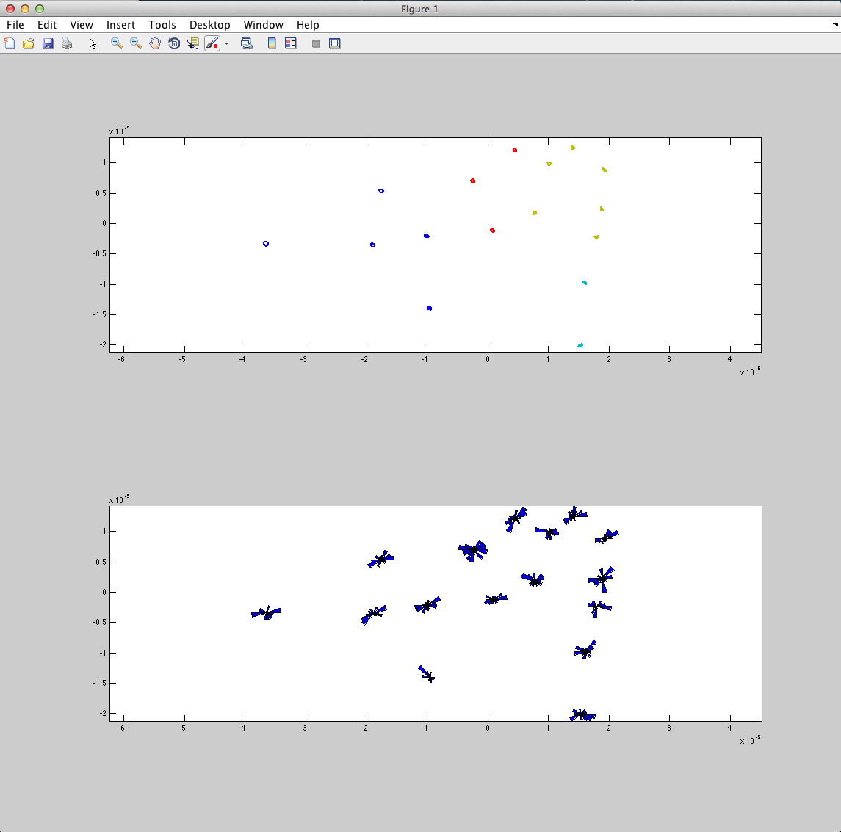

And a detailed view of two shapes in a certain class could look like this:



# Matlab Caveat.

* The experiment folder.
* Run a program in matlab
* Console in matlab.
* What to do if program does not finish as expected.
  + Do you use a matlab version that we have tested (see list)
  + Do you have followed the step as before and used the guidelines in where to place your files
  + Ask a technical person in your team, ideally, someone who is a matlab programmer
  + Ask the authors.
  + How to save figures in matlab in any format you like.
  + File Chooser